The impact of parental housing wealth and inter vivo transfer on children’s wealth and homeownership in China

BACKGROUND

Over the subsequent years since researchers’ attention was shifted to wealth as another distinctive variable than income reflecting economic wellbeing (Spilerman 2000; Keister & Moller 2000), wealth studies have been greatly advanced and moved from its “infancy” to “adolescence” (Killewald 2018). However, wealth research does not receive equal intellectual attention among societies. Existing research mainly focused on advanced capitalist societies, presumably because of the long history of wealth accumulation and wealth’s versatility in facilitating life chance. As a contrast, socialist systems limit the accumulation of private wealth (Szydlik 2004) whose impact is also limited in redistributive economies.

However, it would be astonishing today to see the scarce presence of wealth research in a post-socialist society, China, considering that an earlier Annual Reviews article (Killewald 2017) had zero mentions for wealth studies in China. The intellectual gap would seem frustrating if to consider that different from many post-socialist regimes such as Russia and East European countries who are still suffering from economic downturns, China’s post-socialist trajectory was coupled with a double-digit boom making the world’s leading emerging economy, with simultaneously skyrocketing wealth inequality as well. China has its private wealth rose from around 100% of national income in 1978 to over 450% of national income in 2014, reaching a level close to that in France, the United States, and the UK (Piketty et al., 2017; Piketty et al., 2018). Also, China appears to be converging toward a pattern of inequality found throughout other market economies in which the returns to capital exceed those to labor and capital is more mobile than labor (Davis 2008). Contrary to its present scarcity, wealth studies on China might be promising to offer unique observations considering the rapid wealth accumulation process and changing stratification dynamics in the society. More precisely, this proposition might be supported a focus on the housing asset and a perspective of intergenerational impact.

Without exception compared with other societies (Wolff 2016), housing wealth is the most valuable, and sometimes the only, significant asset for the Chinese middle class, which is even less surprising considering its opaque and low-return financial market (Koss & Shi, 2018). Piketty et al. (2017) pointed out that the strong positive capital gains for non-financial assets (mainly housing) contributed to much of added wealth inequality during the reform era. Also, the state’s weakening role in social welfare provisioning made individuals and families more obliged to prepare themselves a safety net through savings and wealth reserve. These economic factors have made housing asset a demanding consumption yet desirable holdings in Chinese society.

The cumulative nature of wealth had been one of the challenges for wealth studies in advanced societies (Killewald 2017). While mobility literature suggested the inequality should be studied across multiple generations (Hällsten 2014; Jaeger 2012; Lindahl et al. 2015; Mare 2011), it adds challenges to theoretical methodologies, demand for data and statistical complexity. Compared with developed societies, although contemporary patterns of poverty and wealth have their roots in China’s socialist period (Davis 2008), the wealth inequality in China has been recently installed within roughly only two generations. In other words, such a setting might make it easier to investigate transmission and persistence with less wealth-related uncontrollable multi-generational factors in China’s emerging opportunity structure.

LITERATURE REVIEW

Three decades ago, China witnessed the entry of much of the population into the capitalist labor system in a tense period for a society that had not left socialism behind and not really embarked on capitalism (Rocca 2015). Despite the fueled earlier debates on market transition (Nee 1989; Logan 2010; Walder and He 2014; Song and Xie 2014), ongoing intervening institutional arrangements between the market and the post-socialist state created a constantly evolving structure of opportunities (Wu 2019). China’s economic reform weakened labor power as maintained through the hukou system and undermined the role of organizational assets tied to the working units. The roles of authority, skills, and economic capital in generating inequalities, however, have been enhanced (Wu 2019). Looking at economic resources, previous researchers had privileged debates on income over wealth because there had not been time for intergenerational shifts in class position to solidify and shortage of data availability (Davis 2008).

More recently, considering its unequal origin and increasingly amplified impact, Wu (2019) and Xie (2015) have highlighted the increasing role that housing wealth plays in stratification, closely related to but independent of political and human capital. Research utilizing newly available data had documented the overall wealth inequality, distribution and trends in China (Xie and Jin 2015; Gan et al. 2014; Piketty et al. 2018). Some pioneering research has started the investigation of wealth as social determinants of other variables such as labor force participation (Fu et al. 2016), subjective wellbeing (Cheng et al. 2016) and class formation (Chen et al. 2019 and Tang 2019).

Yet another kind of question to ask is: What social processes led some people, but not others, to accumulate wealth? Indeed, some intragenerational observations had been provided. Researches had found variables indicating households’ capacity in the market economy, such as self-employment and higher income, started to emerge as determinants of home wealth (Jin and Xie 2017). Nevertheless, single cohort analysis on wealth determinants might be biased (Wu et al 2018), due to their inability to operationalize the intergenerational covariates in individual attainment, as a result overestimating achieved status while undermining ascribed status. Indeed, wealth is a resource cumulative in nature (Spilerman 2000; Killewald 2017) where the intergenerational transmission can neither be neglected. However, compared with income or human capital whose intergenerational pattern had been explored by researches (such as Wu 2010; 2017), intergenerational inquiry on wealth had been scarce.

Among the few studies that endorsed a multi-generation perspective to look at wealth determinants, Niu and Zhao (2018) found individuals with cadre parents enjoy better housing wealth in a national sample. By including the occupational and institutional mobility change from parents to offspring, Fan and Lu (2018) analyzed housing assets of megacities households and found evidence for stronger cumulative effect for local resident status and state employment since 1998. Following a similar methodology to integrate intergenerational occupational changes, Zhu (2018) analyzed a national sample and concluded that inherited housing would protect offspring from potential downward mobility.

Despite their pioneering effort, studies above suffer from two significant constraints. First, the intergenerational impact in these studies was modeled by occupational and institutional variables of parents, leading to an empirical inability to capture the fact that besides these institutional privileges, the parental generation under reform had accumulated considerable economic resources, which is largely a breakaway from their previous generations. Although the most of the studies pointed out the co-variation of parental economic resources with occupational and institutional advantage, they were not able to incorporate neither wealth nor income (actually many of the parents would have retired thus reporting no income) into the portfolio of parental resources in the model. As a result of ignoring economic variables, the inference made about the impact and transmission of economic resources would be subject to question, and the intergenerational impact of other occupational and institutional status would be biased as well.

Also, existing research designs did not allow empirically access or confirmations to specific mechanisms of intergenerational assistance in housing wealth attainment. A number of qualitative studies in major Chinese cities (Li & Yi, 2007; Or 2017; Li 2010; Zhong 2014; Deng 2018; Fincher 2014; Chen 2017) have demonstrated that the direct financial support from parents has become a significant way of financing home purchase, especially for the younger urban middle class. However, the data of these studies merely involves any evaluation of the actual form or magnitude of parental assistance. Thus, they were not able to account for details or heterogeneity in the transmission process. For example, the magnitude of parental support would not be always perfectly correlated with parental resources, especially for families with multiple children who would receive unequal assistance.

Therefore, two tempting questions on housing wealth attainment remain unaddressed by existing literature. First, after considering non-economic advantages of parents’ generation in the stratification sphere, what is the impact of parents’ accumulated economic resources on offspring’s wealth attainment? Second, how to evaluate the impact of specific institutions and mechanisms that led to such influence?

RESEARCH DESIGN

The constraints of other researches might have largely resulted from the data collection strategy on the parental generation in available data, as explicitly stated by some of them. Household surveys usually only take information of co-residing parents and children, and most longitudinal household surveys in China have not lasted long enough to document a whole cohort of independent offspring (indeed, some researchers had turned to analyze the wealth accumulation process from transition to home ownership on a smaller group, such as Wu 2018 and Ang 2018). In those cases, limited survey answers from children respondents became the only source of information about their parents, which usually do not involve parental wealth.

Acknowledging the challenge in data availability while still trying to overcome the constraints on parental information, this research utilizes an alternative approach amd shifts data collection focus from children’s cohort to parents’ generation. It utilizes samples from a nationally representative social survey covering the assessments of the social, economic circumstances of adults over 45 years old with the baseline survey in 2011, namely The China Health and Retirement Longitudinal Study (CHARLS) (Zhao et al. 2014). With the average birth year of 1955, most in the population of the survey undergo their prime career during the economic transitions in the 1990s. In other words, this sample would seem ideal to capture the first cohort of parents who had realized wealth accumulation.

In the survey, respondents would answer questions about all their children regardless of co-residence status, which provides a representative profile with an average age of 36 of the offspring cohort at their prime of career and midway of wealth accumulation. CHARLS provides decent availability of children information including home ownership and home value, essential information on demographics and other status attainments such as income, education, occupation, hukou, and party membership.

A distinctive advantage of the data is straightforward: several variables focusing on intergenerational transfer between parents and children, which quantifies the material support from parents to each of the children. More precisely, it enables to assess one of the important mechanisms proposed by both domestic and international literature: direct financial support upon children’s marriage, in its most generous form: 6% of children in the sample were gifted while property ownership by parents (through purchase from the market) at their marriage. The average market value of the gift upon transfer is ¥230k, which is significant considering the median household income for the children is between ¥30k and ¥50k, let alone the appreciation potential afterward. Besides, it also records monetary economic support from parents to children (potentially for a housing loan or regular rent), for 4% in the population the magnitude is more than ¥10k in the past year. This information fits well into the inquiry of researching inter vivo transfers as a mechanism of wealth persistence.

Another methodological benefit is CHARLS deployed a life-history in 2014 capturing the change over time in parents’ social status, which offers a solution to measuring the cumulative nature of wealth (Killewald 2017) by, for example, averaging different income in parents’ economic history to reduce measurement error. By constructing more objective measures of lifetime economic attainment of parents, better estimates of them to the offspring would be obtained.

Benefiting a broader framework of knowledge, this research would first offer comparative observations on wealth, which had been advocated to help reveal the macro-level determinants of wealth inequality and mobility (Killewald 2017). Studying how generic capitalist institutions and practices interact with China’s historical, political, and cultural institutions to allocate life chances would hopefully add diversity and comparability to the understanding of specific determinants of wealth levels and inequality, which are also yet to be identified in a broader body of international literature (Semyonov & Lewin-Epstein 2013). Apart from it, the research would also push forward desired advancement in establishing the causal role of endogenous processes (Killewald 2017), namely the interaction between gift, marriage, and homeownership, to illuminate the pathways generating wealth disparities by various variables indicating social origins.

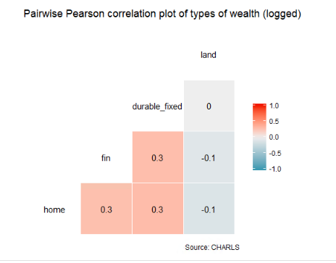

EDUCATION

The education reform in China brought both expansion of educational opportunity and increasing educational inequality. After the cultural revolution which disrupted the Chinese society, the college admission was restored in 1977 and the education system turned to be a meritocracy-based one. Since 1980s, there has been a substantial policy-driven expansion of educational opportunities. By the end of 1980s, primary education enrollment was largely universal; at the end of 1990s, middle school enrollment also reached nearly full level (see attached table). Unlike the experience of western countries, the expansion of higher education since 1990s was a policy-driven initiative that was driven by a sudden policy shift before secondary education was fully developed, to a point event higher than senior high school enrollment. Some researchers had argued that the transition to senior high school is the period that drives the inequality.

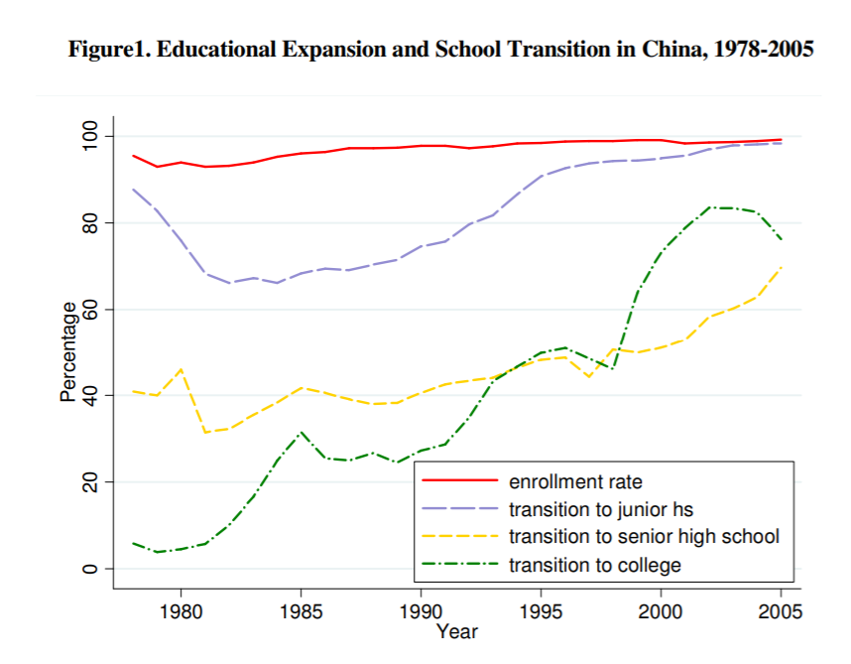

< Changes in educational inequality in China, 1990–2005>

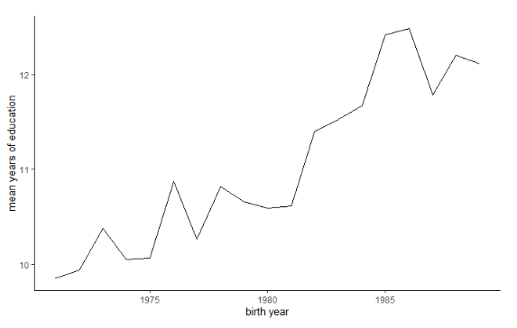

In our data, a significant premium for younger generation can also be identified, consistent with the story that other researchers tell.

Once serving as a central-planned benefit, the education system was decentralized and marketized under the neo-liberal reform. In the 1990s, policy had introduced private education as a more important access to education, and a policy had allowed privatization of some public schools. After 2000s, private tutoring services and extracurricular classes became another dimension of marketization of education. Findings have shown the effect of family background on education was strengthened during the expansion.

With this information, now we turn to analyze the evidence about educational attainment in our dataset. Considering the different landscape of inequalities, we focus only on children who live in the city at the moment of study aged between 25 and 45.

A significant impact of financial asset can be seen. Firstly, the education expense had increase significantly overall. Since 1980s, with increasingly insufficient funding from governments, individual schools ranging from primary schools to colleges had to charge “over-charging fees” for items outside the tuition fee as an alternative to increase tuition fee as an income.

In addition, such impact is probably also relevant with the rent-seeking role that financial resources are playing under the meritocracy education system. Among schools, those “key” schools enjoy more resources and provide education quality than others. Since the education reform, the importance of economic resources has been more evident in both basic education and higher education. In the basic education sphere, “key” primary and middle schools enjoy better resources and provided better quality education, whose enrollment is primarily determined by “nearest school enrollment” and entrance examination scores. However, due to the financial deficit, since 1990s many schools had allowed an option for parents to pay a “school selection fee” (the amount is usually several times of original tuition) to send their children to good schools as “outside-the-plan” students. Together with excessive tuition charge, these grey income takes up more than half in primary and secondary schools nationally in 1999 according to Tsang and Ding 2005.

Different from what is usually more evident in other societies, parental housing value does not have a very strong association with educational attainment of children. Part of the reason is school selection fee provides a more convenient alternative than renting or buying a property in the school district. In the later 2000s, school selection fee had raised heated topic of public debate and the housing sector in China had completed rapid marketization. After purchasing of commodity housing become possible, the channel had been shifting more to the school zone housing.

The durable and fixed asset includes mainly non-productive household consumption items (cars, TV, fridges, etc.) and agricultural production means. A positive impact of it can be seen on household level.